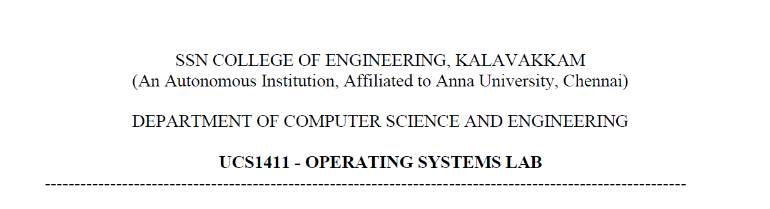

**NETWORKS LAB**

**EXERCISE 11**

Name: Jayannthan P T

Dept: CSE ‘A’

Roll No.: 205001049

Performance Evaluation of TCP and UDP

**Aim:**

To write TCL script to evaluate the performance of TCP and UDP sharing a bottleneck link.

**Code:**

**TCL File**

set ns [new Simulator]

$ns color 1 Blue

$ns color 2 Red

set nf [open out.nam w]

$ns namtrace-all $nf

proc finish {} {

    global ns nf

    $ns flush-trace

    close $nf

    exec nam out.nam &

    exit 0

}

set n(0) [$ns node]

set n(1) [$ns node]

set n(2) [$ns node]

set n(3) [$ns node]

set n(4) [$ns node]

set n(5) [$ns node]

$ns duplex-link $n(0) $n(2) 2Mb 10ms DropTail

$ns duplex-link $n(1) $n(2) 2Mb 10ms DropTail

$ns simplex-link $n(2) $n(3) 0.3Mb 100ms DropTail

$ns simplex-link $n(3) $n(2) 0.3Mb 100ms DropTail

$ns duplex-link $n(3) $n(4) 0.5Mb 40ms DropTail

$ns duplex-link $n(3) $n(5) 0.5Mb 40ms DropTail

$ns queue-limit $n(2) $n(3) 10

$ns duplex-link-op $n(0) $n(2) orient right

$ns duplex-link-op $n(1) $n(2) orient down

$ns simplex-link-op $n(2) $n(3) orient right

$ns simplex-link-op $n(3) $n(2) orient left

$ns duplex-link-op $n(3) $n(4) orient down

$ns duplex-link-op $n(3) $n(5) orient right

set tcp [new Agent/TCP]

$tcp set packetSize_ 1000

$ns attach-agent $n(0) $tcp

set sink [new Agent/TCPSink]

$ns attach-agent $n(4) $sink

$ns connect $tcp $sink

$tcp set fid_ 1

set udp [new Agent/UDP]

$ns attach-agent $n(1) $udp

set null [new Agent/Null]

$ns attach-agent $n(5) $null

$ns connect $udp $null

$udp set fid_ 2

set ftp1 [new Application/FTP]

$ftp1 attach-agent $tcp

$ftp1 set type_ FTP

$tcp set packet_size_ 1000

$ftp1 set rate_ 1mb

$ftp1 set random_ false

set cbr2 [new Application/Traffic/CBR]

$cbr2 attach-agent $udp

$cbr2 set type_ CBR

$cbr2 set packet_size_ 1000

$cbr2 set rate_ 1mb

$cbr2 set random_ false

$ns at 0.0 "$ftp1 start"

$ns at 0.0 "$cbr2 start"

$ns at 5.0 "$ftp1 stop"

$ns at 5.0 "$cbr2 stop"

$ns at 4.9 "$ns detach-agent $n(0) $tcp ; $ns detach-agent $n(4) $sink ; $ns detach-agent $n(1) $udp ; $ns detach-agent $n(5) $null"

$ns at 5.0 "finish"

$ns run

**Awk file for UDP**

BEGIN {

recvdSize = 0

transSize = 0

startTime = 400

stopTime = 0

}

{

event = $1

time = $3

send_id = $5

rec_id = $7

pkt_size = $11

flow_id = $17

type=$9

# Store start time

if (send_id == "1") {

if (time < startTime) {

startTime = time

}

if (event == "+") {

# Store transmitted packet's size

#transSize += pkt_size

transSize+=1

}

}

# Update total received packets' size and store packets arrival time

if (event == "r" && rec_id == "5") {

if (time > stopTime) {

stopTime = time

}

# Store received packet's size

if (flow_id == "2") {

#recvdSize += pkt_size

recvdSize+=1

}

}

}

END {

printf("UDP throughput: %.2f packets/sec\n",recvdSize/stopTime)

#printf("%i\t%i\t%.2f\t%.2f\t%.2f\n", transSize, recvdSize, startTime, stopTime,recvdSize/stopTime)

}

**Awk file for TCP**

BEGIN {

recvdSize = 0

transSize = 0

startTime = 400

stopTime = 0

}

{

event = $1

time = $3

send_id = $5

rec_id = $7

pkt_size = $11

flow_id = $17

type=$9

# Store start time

if (send_id == "0") {

if (time < startTime) {

startTime = time

}

if (event == "+") {

# Store transmitted packet's size

#transSize += pkt_size

transSize+=1

}

}

# Update total received packets' size and store packets arrival time

if (event == "r" && rec_id == "4") {

if (time > stopTime) {

stopTime = time

}

# Store received packet's size

if (flow_id == "1") {

#recvdSize += pkt_size

recvdSize+=1

}

}

}

END {

printf("TCP throughput: %.2f packets/sec\n",recvdSize/stopTime)

#printf("%i\t%i\t%.2f\t%.2f\t%.2f\n", transSize, recvdSize, startTime, stopTime,recvdSize/stopTime)

}

**Output:**

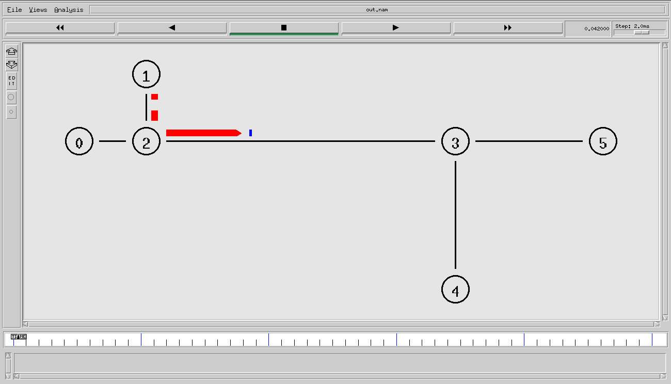

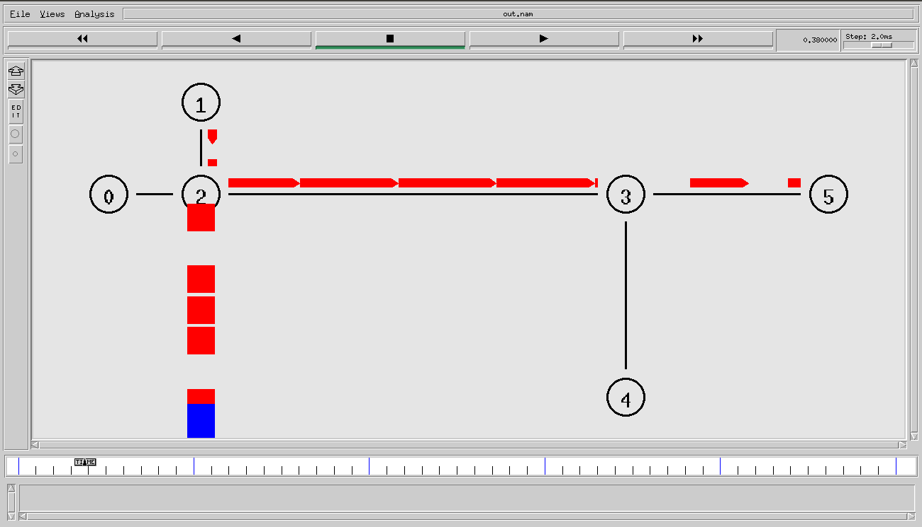

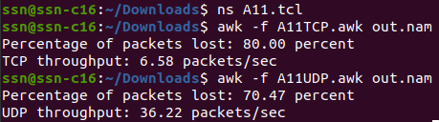

**Learning outcome:**

Learnt to simulate and evaluate the performance of TCP and UDP sharing a bottleneck link has been written and executed.